Turning off the Encapsulation Inactivity Timeout

- Go to the following web page to download the Molex Ethernet/IP tool
http://www.molex.com/mx_upload/superfamily/iccc/EtherNet_IPTool.html
They will require you to enter some information for the download, the zip file will be emailed to you.

- Run the tool, and enter the IP address of the Ethernet/IP card on the top right. Make you’re your PC is set to the same subnet in the Network and sharing center. After this is done go to the “Explicite Message” tab.
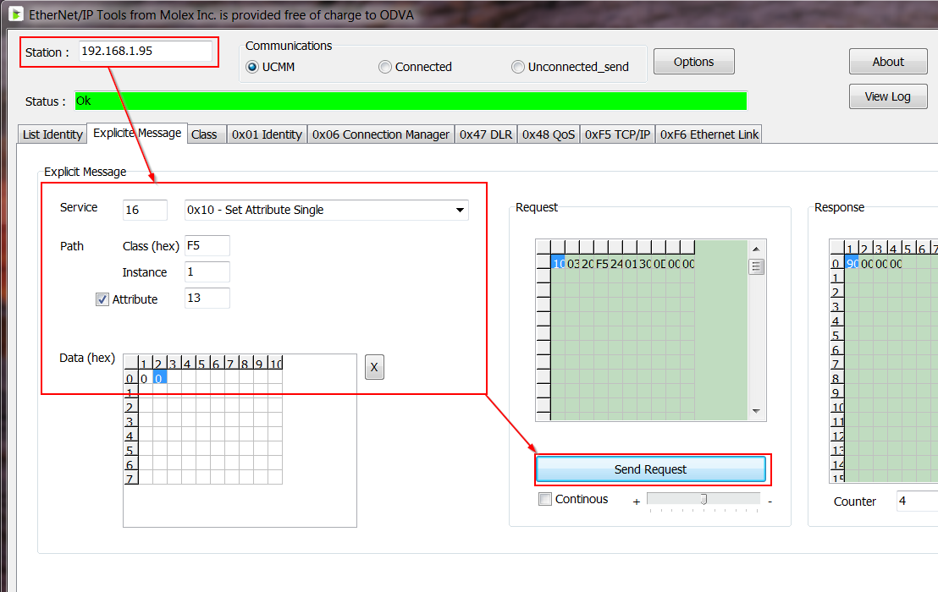
In this tab, set the following
Service drop down = 0x10 – Set Attribute single
Class (hex) = 0xF5
Instance = 1
Attribute = 13
Data (hex) = 0 Note: Enter 0 for the first to data blocks in the grid
- Hit Send Request. The Encapsulation Inactivity timeout is now disabled.

