Hi kyle,
I tested server & cilent configurations.
First I make ubuntu VPN server and then connect client(Windows PC) with ubuntu VPN server. It connects and working fine.
After that I put those same client configuration files in flexy via FTP & in flexy GUI.
That is shown in below image.
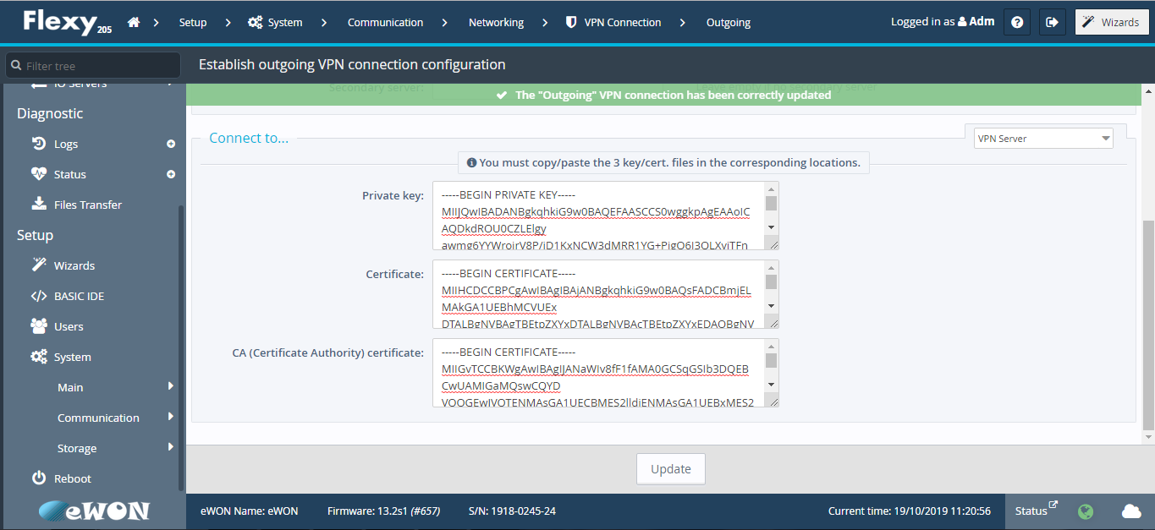
After putting that configuration files in flexy GUI, I have facing one difficulty that when I refresh the browser page, my private key will automatically changed.
That is shown in below image.
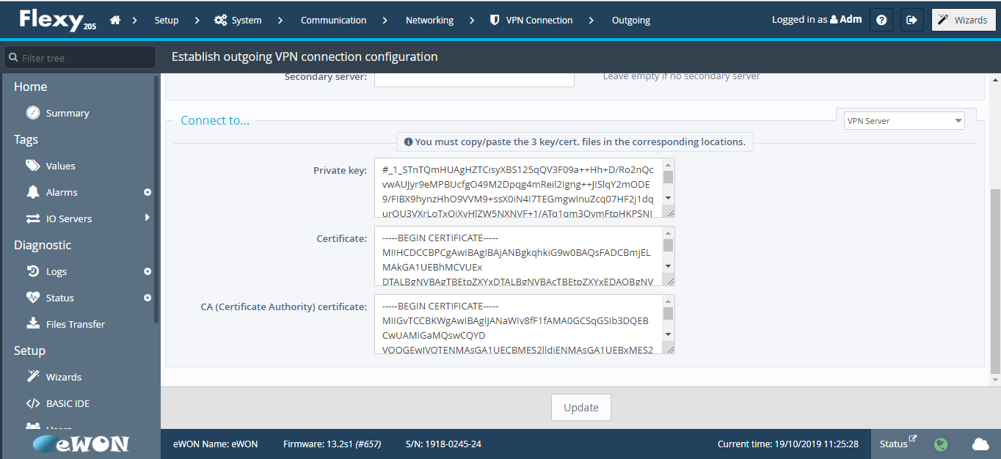

I have attached my Server.ovpn & Client.ovpn files for your reference.
Server.ovpn (Ubuntu)
port 1194
proto udp
dev tun
ca /home/tirths/OpenVPN/easy-rsa/keys/ca.crt
cert /home/tirths/OpenVPN/easy-rsa/keys/ServerVPN.crt
key /home/tirths/OpenVPN/easy-rsa/keys/ServerVPN.key
dh /home/tirths/OpenVPN/easy-rsa/keys/dh4096.pem
server 10.10.10.0 255.255.255.0
ifconfig-pool-persist ipp.txt
keepalive 10 30
cipher AES-256-CBC
comp-lzo
persist-key
persist-tun
verb 3
Client.ovpn (Windows)
client
dev tun
proto udp
remote 192.168.101.67
resolv-retry infinite
comp-lzo
nobind
persist-key
persist-tun
ca "C:\\Users\\niravp\\Downloads\\openvpn\\ca.crt"
cert "C:\\Users\\niravp\\Downloads\\openvpn\\ClientVPN.crt"
key "C:\\Users\\niravp\\Downloads\\openvpn\\ClientVPN.key"
--remote-cert-tls server
cipher AES-256-CBC
verb 3
Thank you in advance.

