Transparent CAN mode
Supported / not supported functionality:
- transparent CAN functionality
see chapter 8.2 Transparent CAN Interface Functions of the manual
CAN_SEND
CAN_RCV
CAN_CTRL
Get Diagnostic Information
is not supported by CANopen mode: CANopen Manager / CANopen Slave
- transparent CAN mode does not support the CANopen interface functions
see chapter 8.1 CANopen Interface Functions of the manual
SDO Read / Write
Get Process Data In
Set Process Data Out
Get Node & Network Status

CANopen Manager / Slave mode

Transmission of TPDOs by the CM CANopen:
- the transmission of TPDOs is controlled by the CANopen stack of the CM CANopen
- the CM CANopen knows
based on the downloaded configuration that includes the configuration of the PDOs
=> which CAN identifier is to be used by a TPDO
note: PDOs are assigned by the CAN identifier (CAN-ID)
=> which data are transferred by a TPDO
where to get the data that shall be transmitted
=> the transmission of a TPDO is triggered by its transmission type
that is specified by CANopen
- the customer is responsible for the data that are written to the CM CANopen
by Set Process Data Out
- CM CANopen is responsible for the transmission of the TPDOs

Reception of RPDOs by the CM CANopen:
- the reception of RPDOs is controlled by the CANopen stack of the CM CANopen
- the CM CANopen knows
based on the downloaded configuration that includes the configuration of the PDOs
=> which RPDO corresponds to the received PDO
=> which data are transferred by the received PDO and where to copy the received data
=> note: PDOs are assigned by the CAN identifier (CAN-ID)
screenshot of an example:
- CM CANopen uses the CANopen node id 127
- the slave device uses the CANopen node id 1
an enabled RPDO of the slave device in PDO Parameters Node-ID 1 is assigned with the TPDO of the CM CANopen that uses the same CAN-ID
an enabled TPDO of the slave device in PDO Parameters Node-ID 1 is assigned with the RPDO of the CM CANopen that uses the same CAN-ID
note PDOs are assigned by the CAN-ID that is independent of the PDO number
- example:
=> RPDO 1 of the slave is enabled and uses the CAN-ID 201h
=> RPDO 1 receives the data of TPDO x of the CM CANopen that uses the CAN-ID 201h
screenshot RPDO 1 of the slave device
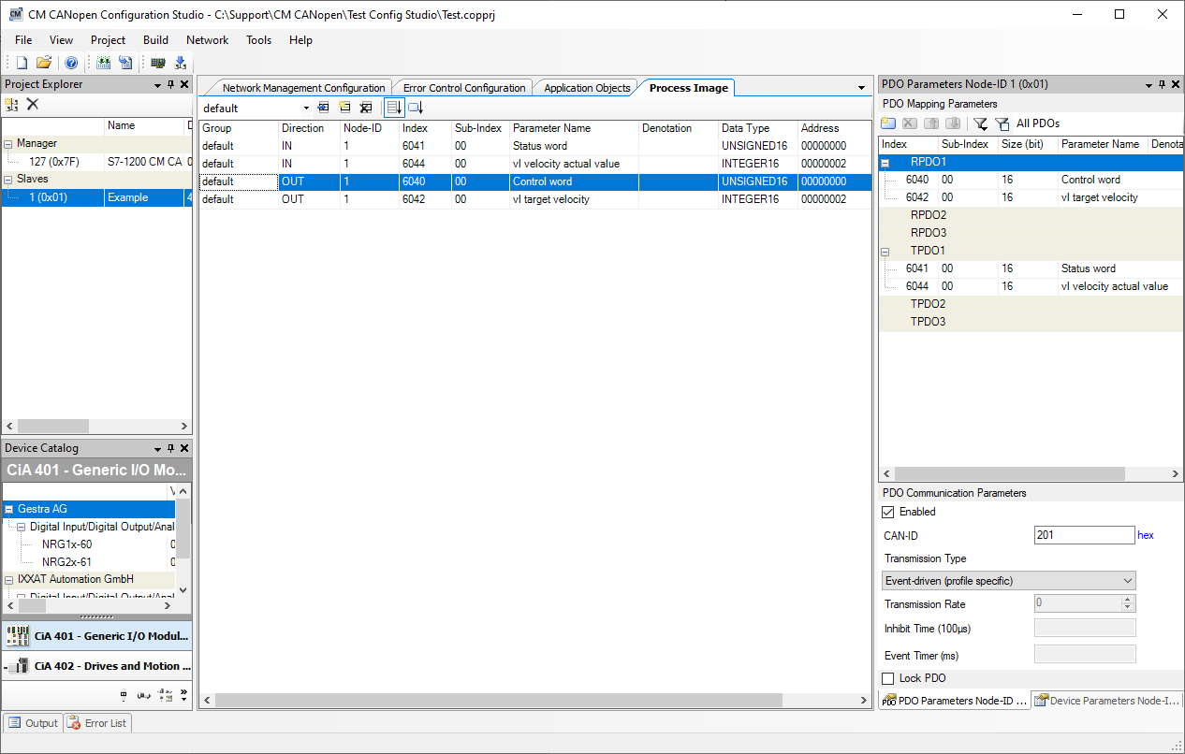
screenshot of the assigned TPDO of the CM CANopen
note: RPDO and TPDO must not use the same PDO number
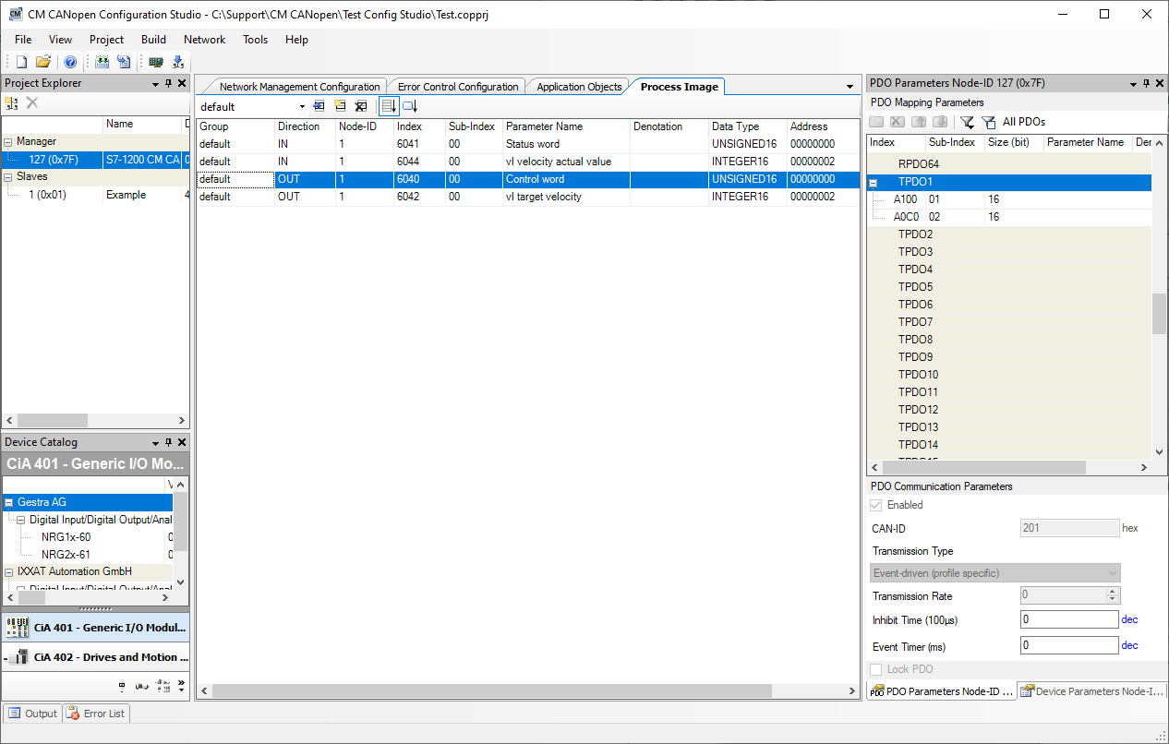

- example:
=> TPDO 1 of the slave is enabled and uses the CAN-ID 181h
=> TPDO 1 is received by RPDO x of the CM CANopen that uses the CAN-ID 181h
screenshot TPDO 1 of the slave device
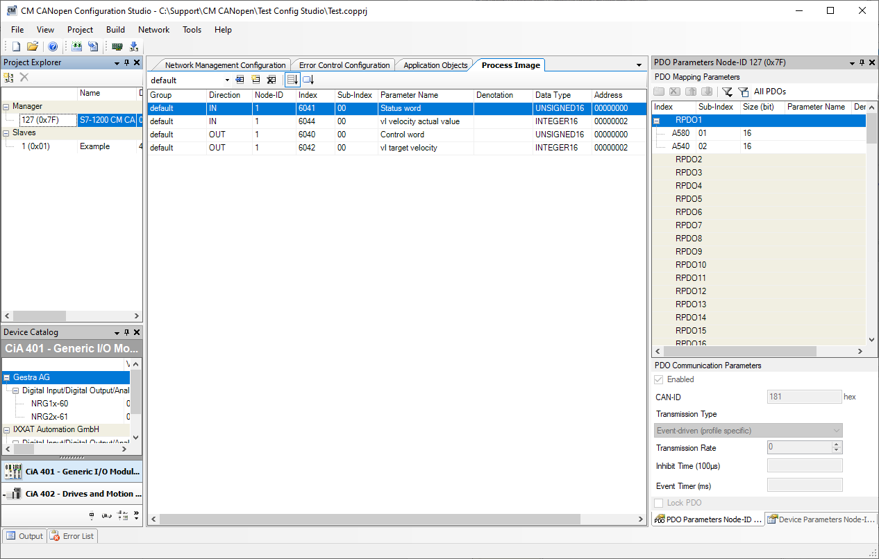
screenshot of the assigned RPDO of the CM CANopen
note: RPDO and TPDO must not use the same PDO number

