Swapping Netbiters
Using Netbiter Argos

SOLUTION SHEET
AM-1012-00 1.0 en-US ENGLISH

Important User Information

Disclaimer

The information in this document is for informational purposes only. Please inform HMS Industrial Networks of any inaccuracies or omissions found in this document. HMS Industrial Networks disclaims any responsibility or liability for any errors that may appear in this document.

HMS Industrial Networks reserves the right to modify its products in line with its policy of continuous product development. The information in this document shall therefore not be construed as a commitment on the part of HMS Industrial Networks and is subject to change without notice. HMS Industrial Networks makes no commitment to update or keep current the information in this document.

The data, examples and illustrations found in this document are included for illustrative purposes and are only intended to help improve understanding of the functionality and handling of the product. In view of the wide range of possible applications of the product, and because of the many variables and requirements associated with any particular implementation, HMS Industrial Networks cannot assume responsibility or liability for actual use based on the data, examples or illustrations included in this document nor for any damages incurred during installation of the product. Those responsible for the use of the product must acquire sufficient knowledge in order to ensure that the product is used correctly in their specific application and that the application meets all performance and safety requirements including any applicable laws, regulations, codes and standards. Further, HMS Industrial Networks will under no circumstances assume liability or responsibility for any problems that may arise as a result from the use of undocumented features or functional side effects found outside the documented scope of the product. The effects caused by any direct or indirect use of such aspects of the product are undefined and may include e.g. compatibility issues and stability issues.

Table of Contents Page
1 Preface 5
1.1 About This Document 5
1.2 Document history 5
1.3 Related Documents 5
1.4 Document Conventions 5
1.5 Trademark Information 5
2 Introduction 6
2.1 Requirements 6
3 Procedure 7

This page intentionally left blank

Preface

About This Document
Process for replacing a Netbiter in an Argos account with a new Netbiter.
For additional related documentation and file downloads, please visit www.netbiter.com/support.

Document history

Version | Date | Description
1.0 | 2022-01–25 | First release

Related Documents

Document | Author | Document ID
Netbiter Argos Administration Manual | HMS | HMSI-168-104
Netbiter EC300 Series User Manual | HMS | SCM-1202-012

Document Conventions
Numbered lists indicate tasks that should be carried out in sequence:

- First do this

- Then do this Bulleted lists are used for:
• Tasks that can be carried out in any order

• Itemized information

- An action

→ and a result

User interaction elements (buttons etc.) are indicated with bold text.

Program code and script examples

Cross-reference within this document: Document Conventions, p. 5

External link (URL): www.hms-networks.com

WARNING

Instruction that must be followed to avoid a risk of death or serious injury.

Caution

Instruction that must be followed to avoid a risk of personal injury.

Instruction that must be followed to avoid a risk of reduced functionality and/or damage
to the equipment, or to avoid a network security risk.

Additional information which may facilitate installation and/or operation.

Trademark Information
Anybus® is a registered trademark of HMS Industrial Networks AB. All other trademarks mentioned in this document are the property of their respective holders.

Introduction
Introduction on the process:
- Configure new Netbiter
- Change old Netbiter with new Netbiter

Requirements
There are some requirements to use document:
    - Active Netbiter Argos account.
    - Netbiter EC300 Series device.
    - Activation codes for both Netbiters

Procedure

    - Log into your Argos account as an administrator at www.netbiter.net

    - Navigate to Management > all systems > add system
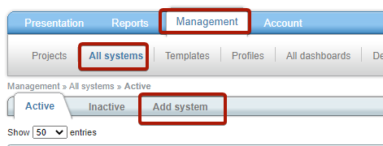

    - Add your new device to your account, but do not activate it .

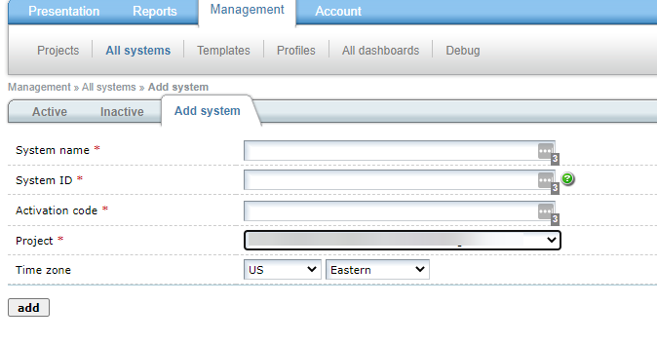

    - Navigate to your Active systems and select the replace option for the device you want to replace.
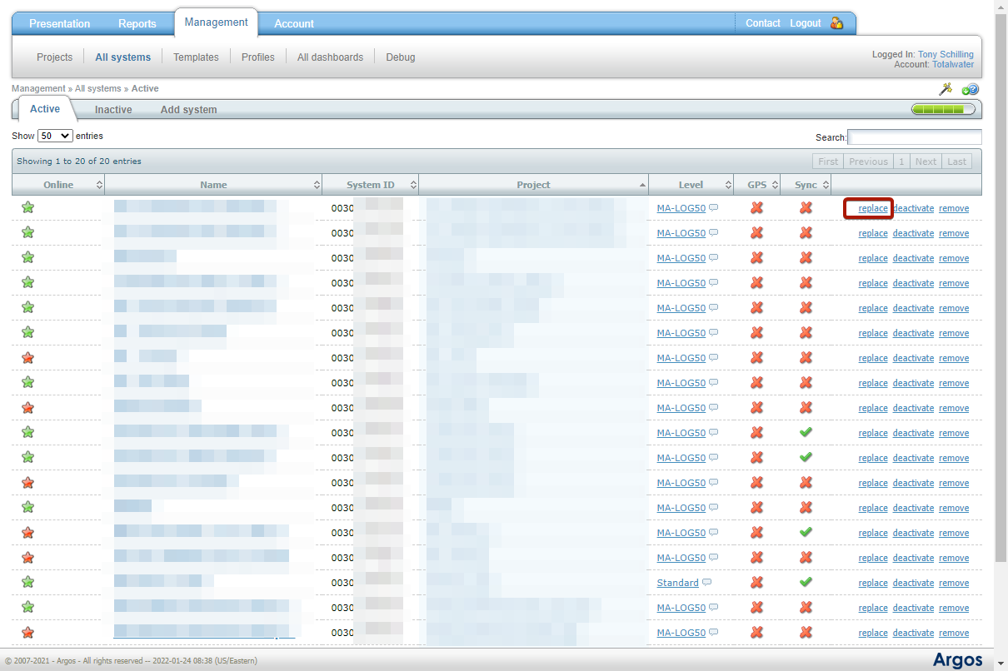

    - Enter the activation code for the old device then select your deactivated device and enter its activation code in the line below. Then select replace.
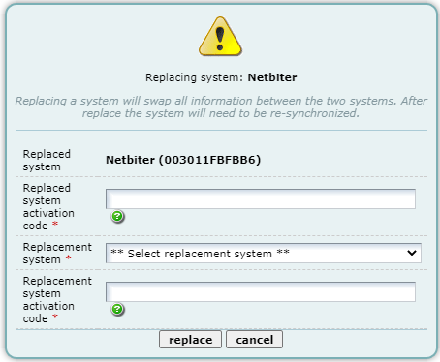
Your devices will now be replaced. Look at the activation codes to verify the results. You will see the old system under Inactive.

This page intentionally left blank

© 2022 HMS Industrial Networks
Box 4126
300 04 Halmstad, Sweden

info@hms.se AM-1000-00 en-US

