Fieldbus Configuration: Modbus RTU
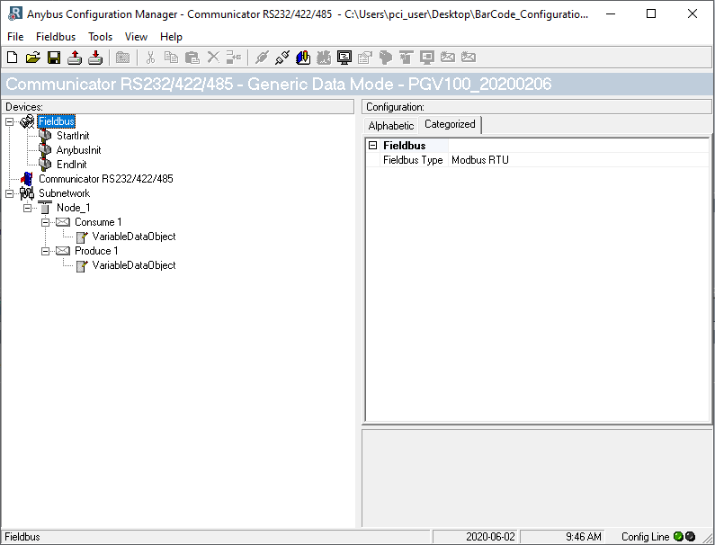
Gateway Configuration: Generic Data Mode.
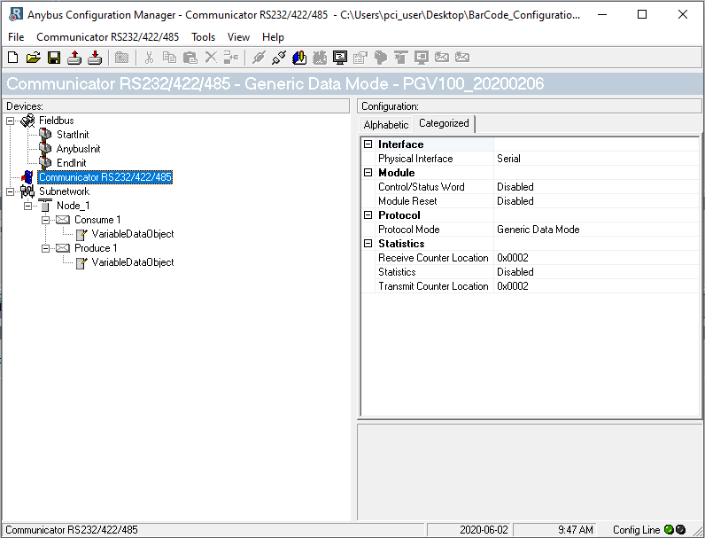

Subnetwork Configuration. RS485. Baudrate: 57600 (minimum speed of the sensor). 8-E-1
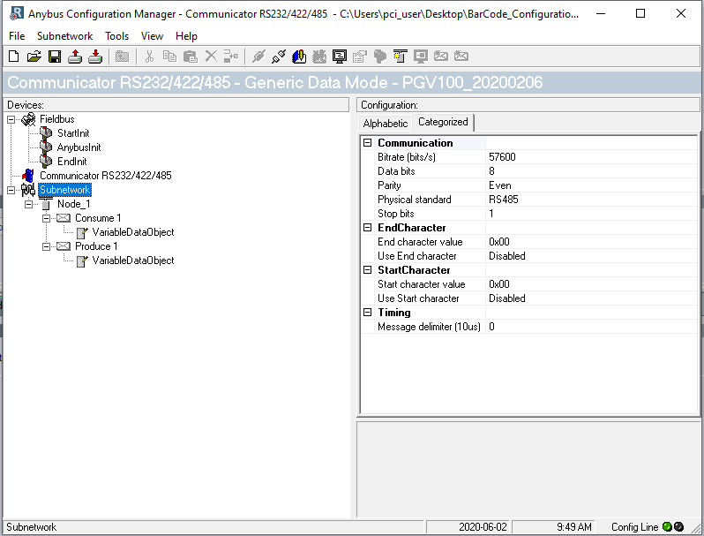
Node Configuration: Slave Addr. 1
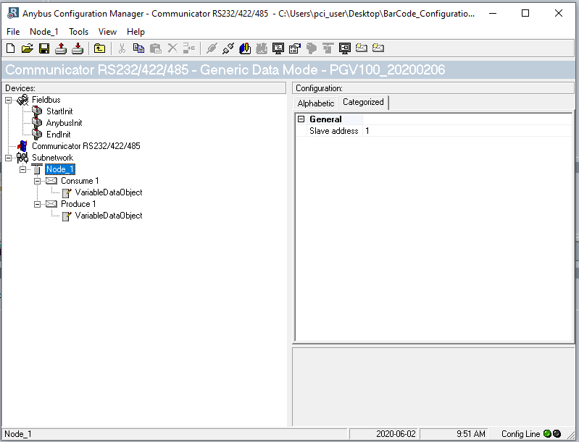

Consume transaction.
In order to avoid the LED#5 on in red (transaction error/Time out or subnet stopped) I put the offline timeout time in 0. Is this ok??
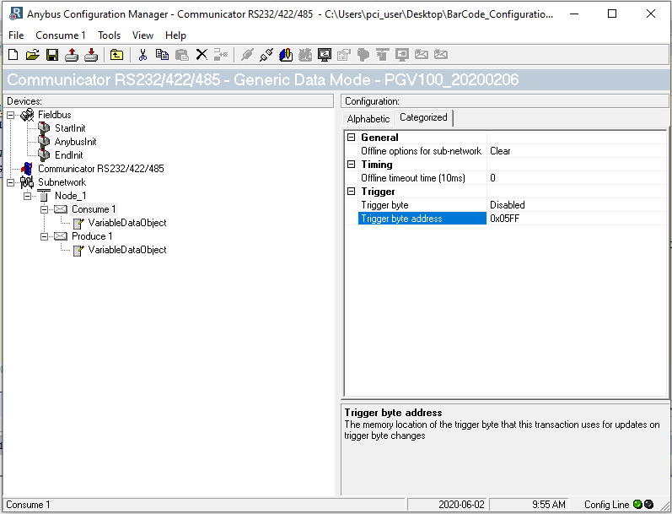

Consume Data:
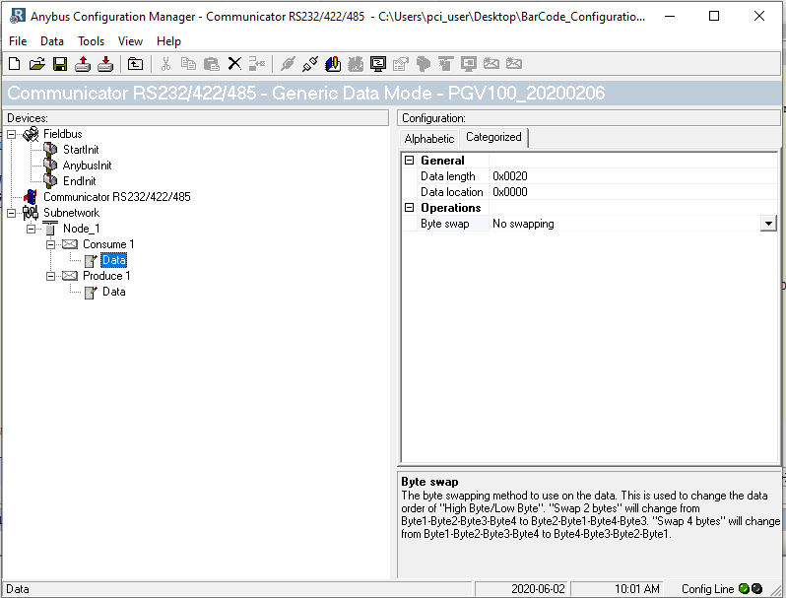

Produce Transaction:
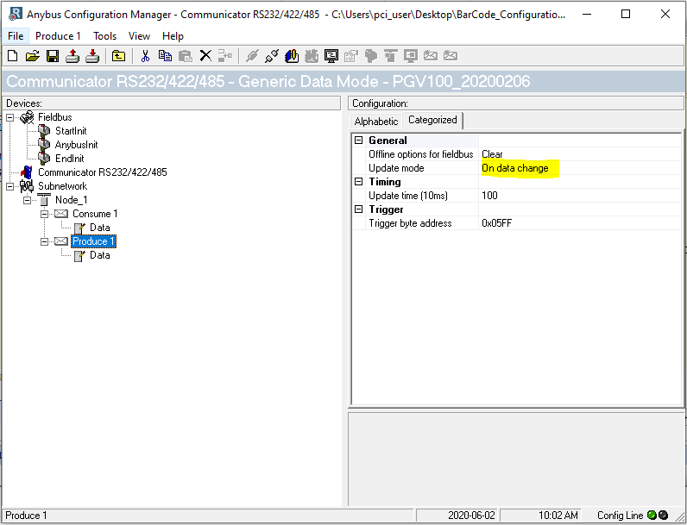
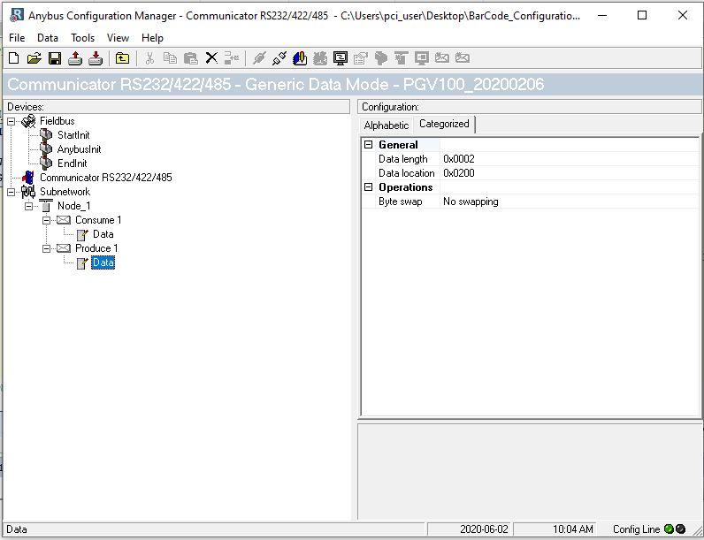

Anybus Configuration switch, Status and connections
