Publish tags in Modbus TCP

The eWON allows you to publish acquired or internal Tags. Using this feature, an external Modbus TCP client can read the Tags value out of the eWON. For example, a Modbus client software running on a PC which is connected to the eWON using Ethernet (local network or remote connection) could then read the values which eWON polls on the PLC even if the PLC is using a different protocol.
First, enable the Modbus TCP Server on the Ewon under Tags > IO Servers > Modbus:
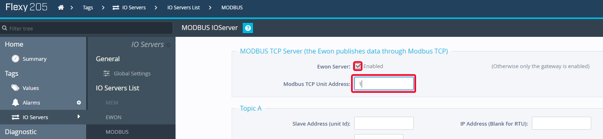
It defaults to Modbus TCP Unit Address 100, but you may want to change that to 1, which most Modbus scanners will read first.
To publish a Tag, go to the Tag Setup page (Tags > Values > Mode:Setup) and click on the Tag that you want to publish.
Click “Edit” and in the "Tag Visibility" section to indicate how the Ewon should publish the Tag.
To publish the Tag in Modbus TCP you will need to configure it like this:
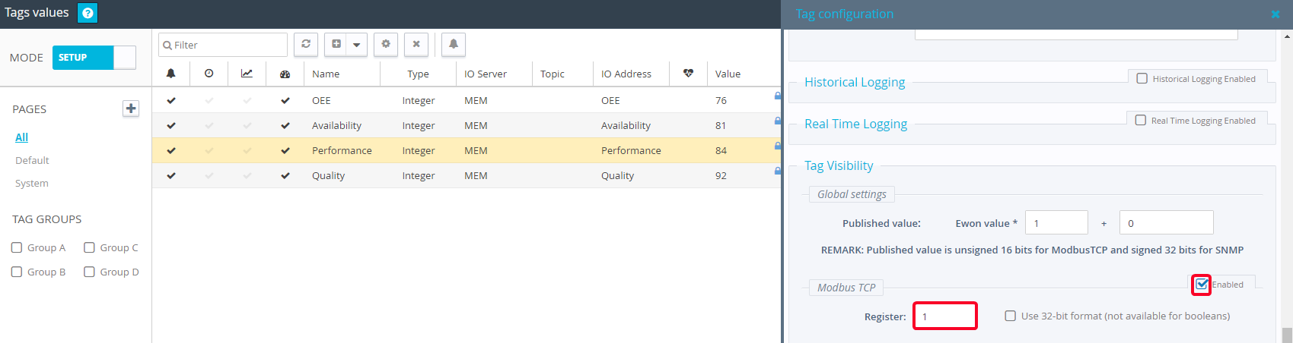
Make sure “Modbus TCP” is enabled and indicate the Modbus register on which the Ewon should publish the tag value.

