Connect Cosy 131 to MicroLogix 1500
Parts needed
- 9-pin to serial >P66-4985
- Serial converter to USB, all USB drivers must have been previously installed P66-42052

- The Ewon firmware must have the latest version, otherwise, this setup will not work. We used 14.6 when bench testing
- Configure Ewon as usual.
- After activating the Talk2M key and verifying the EWON is online follow the procedure
- Connect to specific EWONEWON properties Configure LAN Devices & Firewall
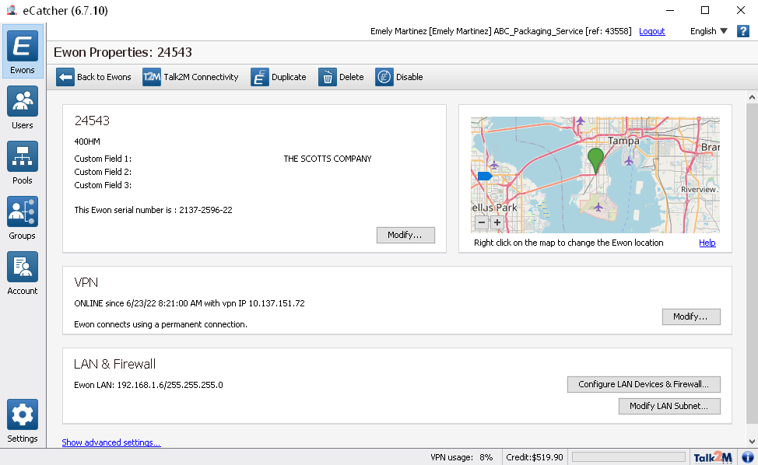

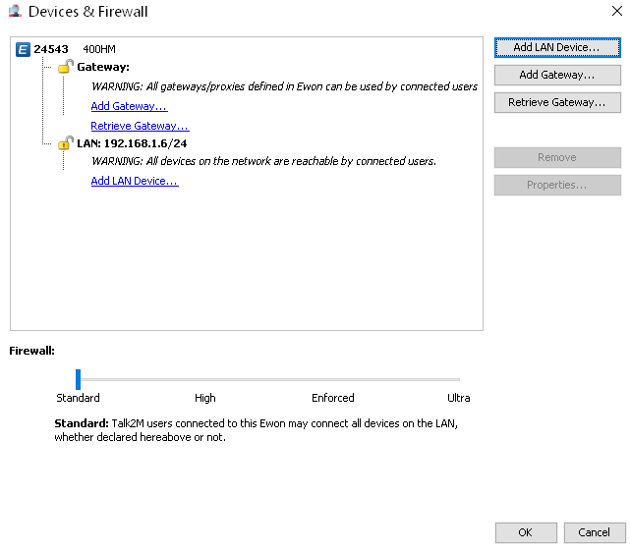
Select Add Gateway

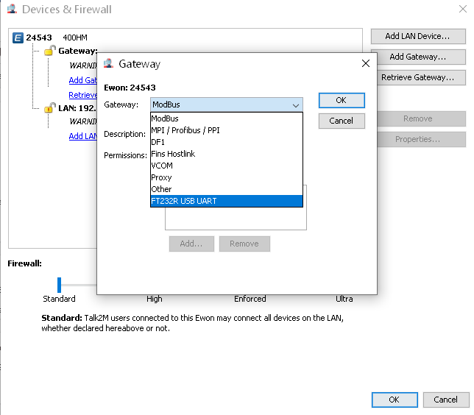
Select FT232R UART

Disconnect and go offline for the changes to save.
Connect again Connect option should be available. 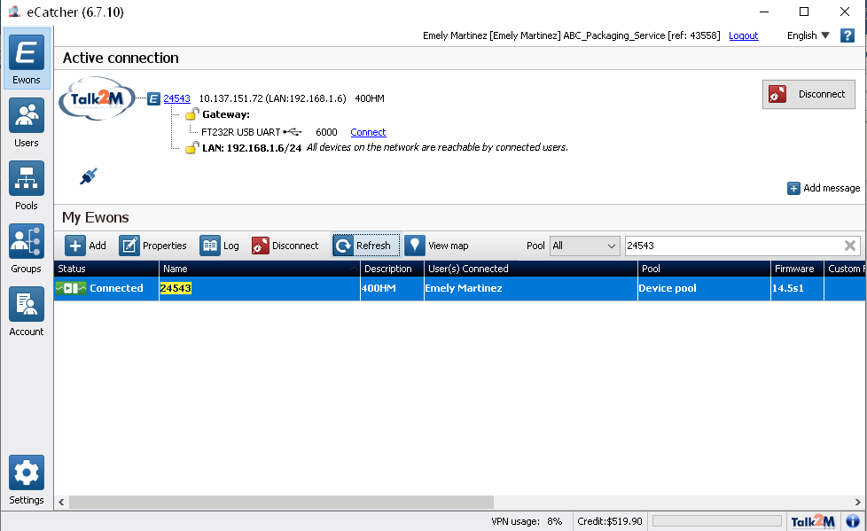
If the option to connect to Gateway FT232R USB UART is not available DISCONNNECT and cycle power on the EWON. Remove USB CABLE from EWON. Turn on the EWON and connect USB CABLE, proceed to CONNECT.

If the FT232R USB UART does not appear, open device manager, USB Serial port must appear, if not, the connection to the PLC or other devices will not be possible.
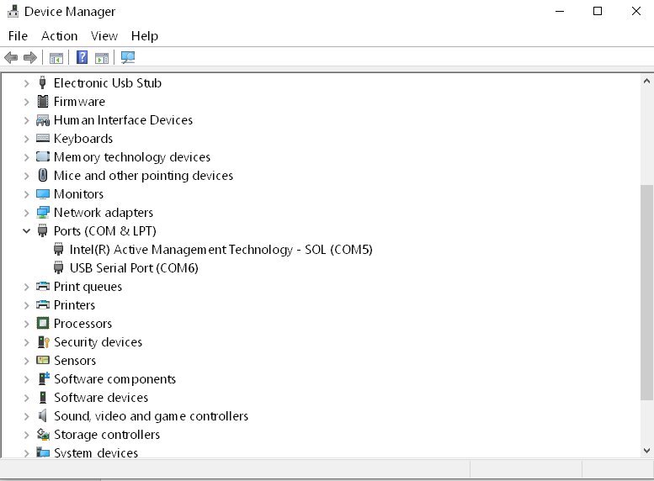

If option is available, CONNECT to FT232R USB UART and open RSLinx Classic
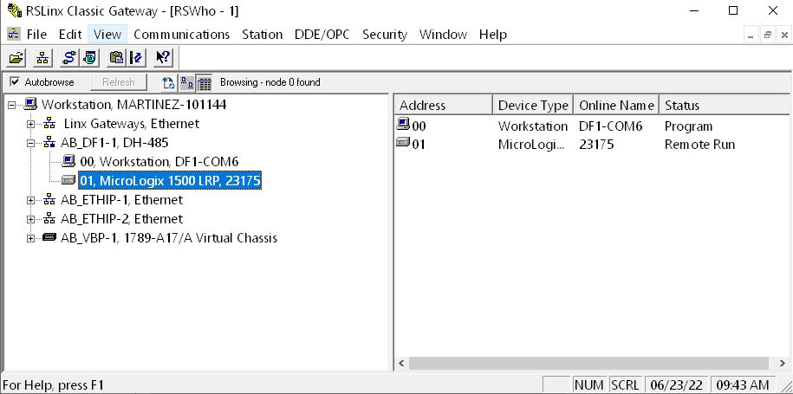
MicroLogix must be available for remote connection.
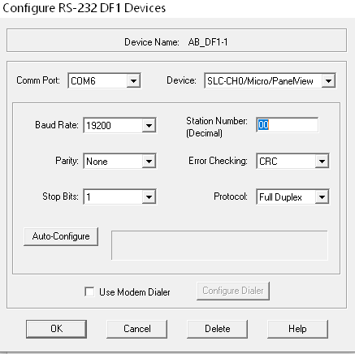
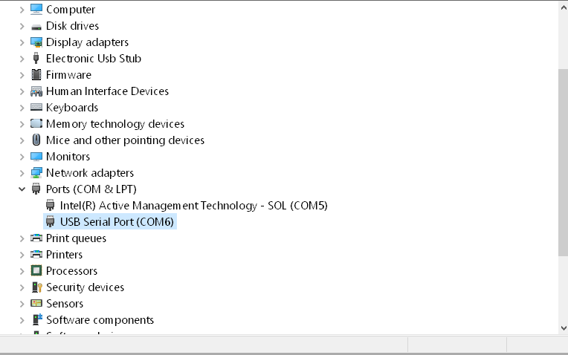
If not available, make sure the Port selected in the driver is the same as the one in device manager

Important notes:
Wireless connection is possible, however, is not very reliable and therefore not recommended.
For the wireless connection to work, connect on ecacher, when online make sure the USB port shows on Device manager. If available open RsLinx Classic.

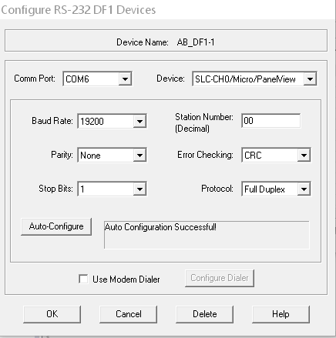
Communications> Configure Drivers > Select RS-232 DF1 devices> Add new

Select COM6 > Auto Configure > Ok

*Device should be: SLC-CH0/MICRO/PANELVIEW

