Enable email based on user status
Created By: Tim Beaulieu
Version 1.0
Created on: 4/27/2020
Last Updated: 4/28/2020

Contents
Step 1: eWON Basic Setup 2
Step 2: Bolt Basic Setup 3
Step 3: PC settings 4

Abstract:
This guide will be useful if you want to make the Flexy only send emails to employees that are currently working. The code looks at the tags created for each user and will add their email or phone number to the send list depending on the boolean value of their user.

Step 1: Creating a user list
- Go to your values page and create a page for your users.
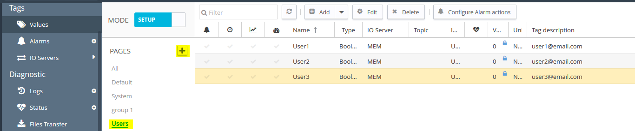
Figure 1: Shows the user page as well as the user tags
- Create a tag for each one of your users, make sure that you set the tag description to be the email for that user. Make the tag be a Boolean MEM tag. Make sure to set the Topic Name to RET. This will make it so the value will stay the same even if the device powers down.
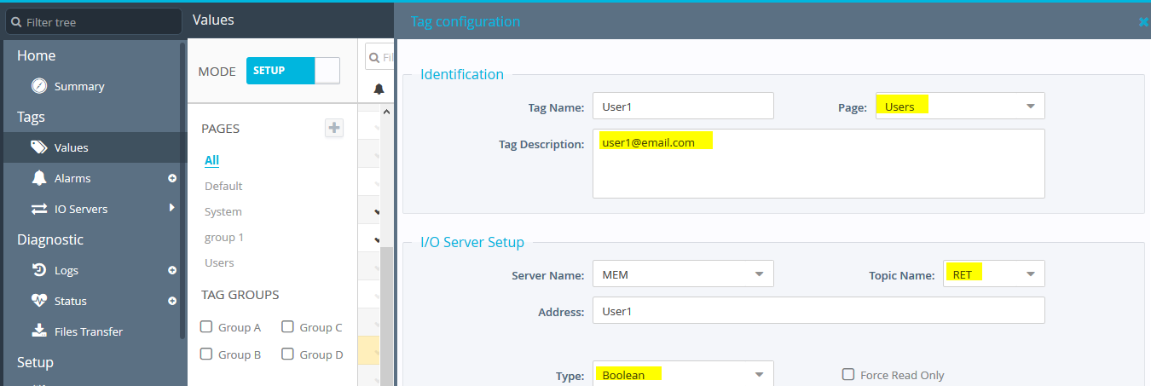
Figure 2: Shows the tag setup for each of the users
- Copy the code in the section below and paste it in your Init section of the Basic IDE.
Note- For the EmailTo section there is a character limit of 248 including commas and spaces. This code can be modified to use EmailCC (ECC) or SMS (STO) instead of the EmailTo (ETO) tag parameter in the code.

Used code:
Tset 1, 30 //every 30 seconds it will update the sendlist
Ontimer 1, "goto renew_sendlist"
renew_sendlist:
sendlist$ = "" // resets the sendlist back to empty
Goto Active_users:
End
Active_users:
n% = GETSYS PRG,"NBTAGS"
i% = 0
//Browse all Tags
For i%=0 To n%-1
SETSYS TAG, "LOAD", -i%
PageId% = VAL GETSYS TAG, "PageId" //looks at your list of user tags
value$ = GETSYS TAG, "TagValue" //grabs the value of the user (0 to remove, 1 to add)
//Print value$
SETSYS TAG, "ETO", sendlist$
SETSYS TAG, "SAVE"
If PageId% = 4 AND value$ = "1" Then // looks only at the tags in that group and checks their value
email$ = Getsys TAG, "Description" // grabs the desription that includes the email
sendlist$ = sendlist$ + email$ + "," // will keep adding onto the for users that have a value of 1
//Print sendlist$
ENDIF
Next i%
If i% = n% Then //once it's gone through every user it will then go onto the next step
Goto setmail:
Endif
End

setmail:
n% = GETSYS PRG,"NBTAGS"
i% = 0
//Browse all Tags
For i%=0 To n%-1
SETSYS TAG, "LOAD", -i% //loads all of the tags info
SETSYS TAG, "ETO", sendlist$ // sets every tag's emailto section to be the emails defined by the user list
SETSYS TAG, "SAVE" // saves the tags
Next i%
End

