eWON Flexy 201 is communicating with Modicon PLC M340 (CPU part# BMX P34 2020) via Modbus TCP:
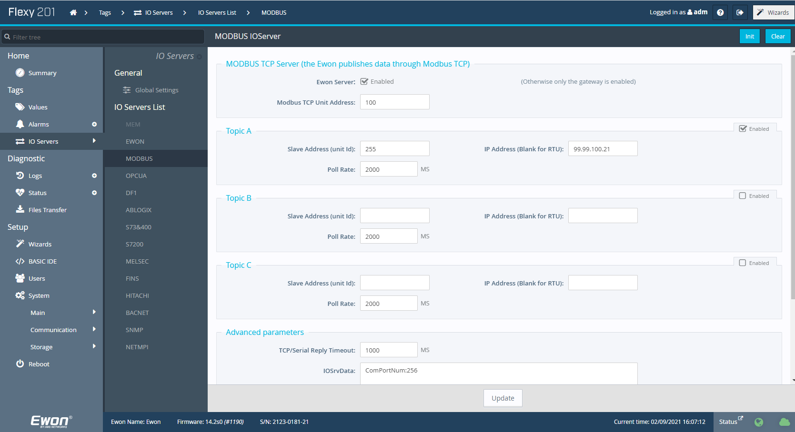
A PLC tag name “Eff_DO_SCADA” with Address “%MW1202” (Real Type) need to be added to eWON tags, but instead of “41202”, I had to use “41204” for the address in eWON, then will get the correct reading. Why the address will be shifted by 2?
A modifier “H” is needed at the end of the address for the float type of tag:
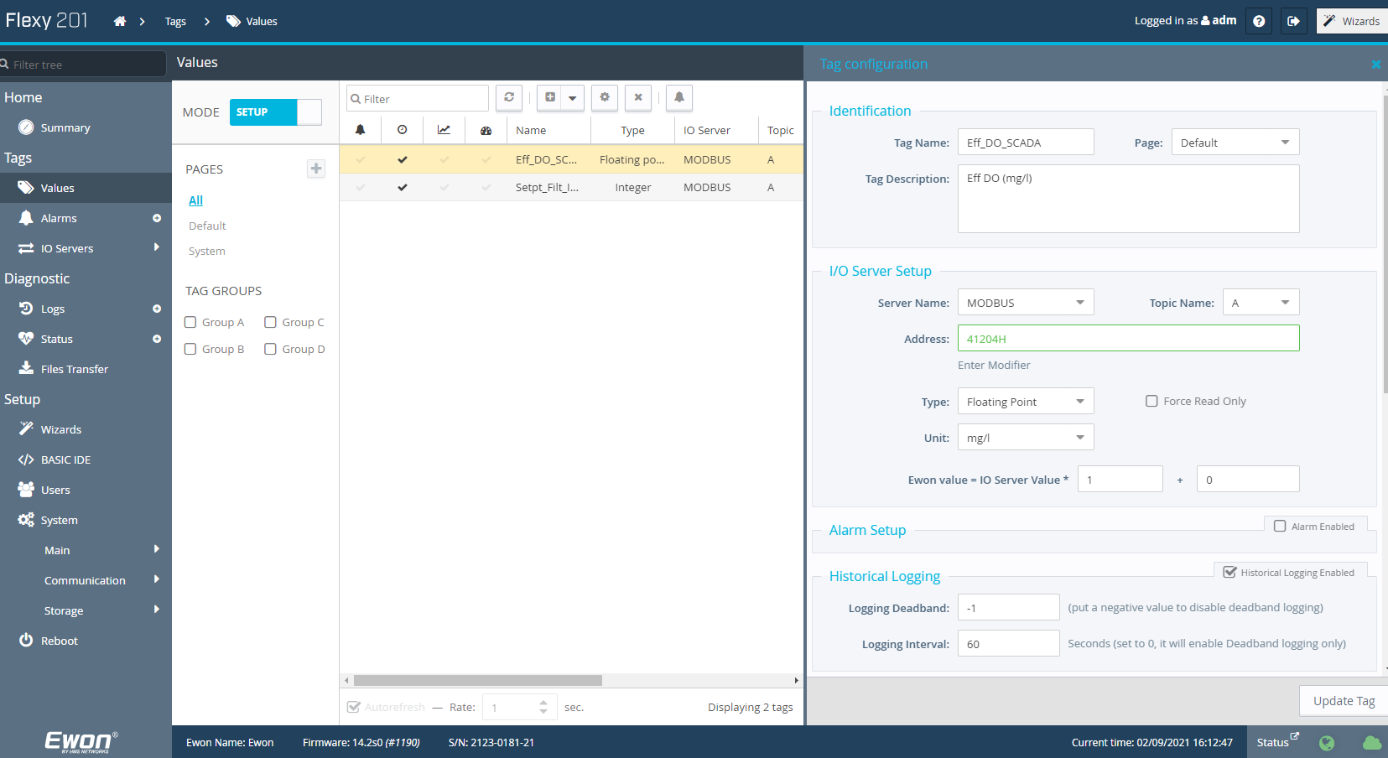

Does below “Modbus TCP” need to be Enabled? What does “Register” enter box mean?
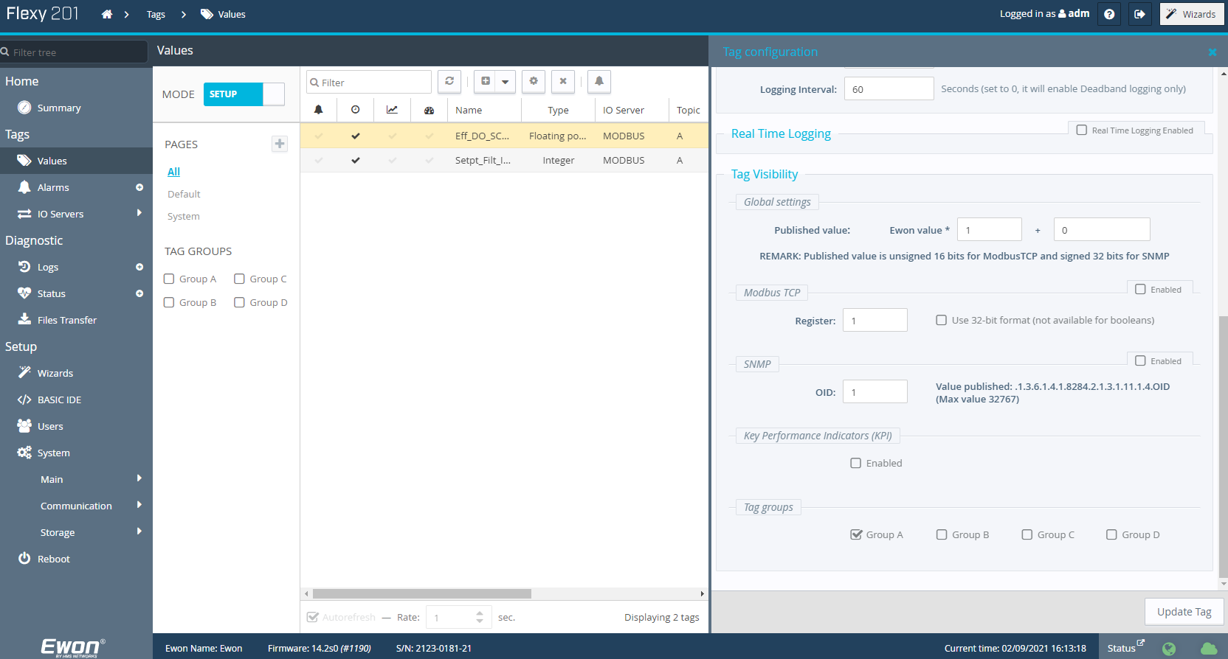

A PLC tag name “Setpt_Filt_Inf_ROF” with Address “%MW129” (Int Type) need to be added to eWON tags, but instead of “40129”, I had to use “40130” for the address in eWON, then will get the correct reading. Why the address will be shifted by 1?
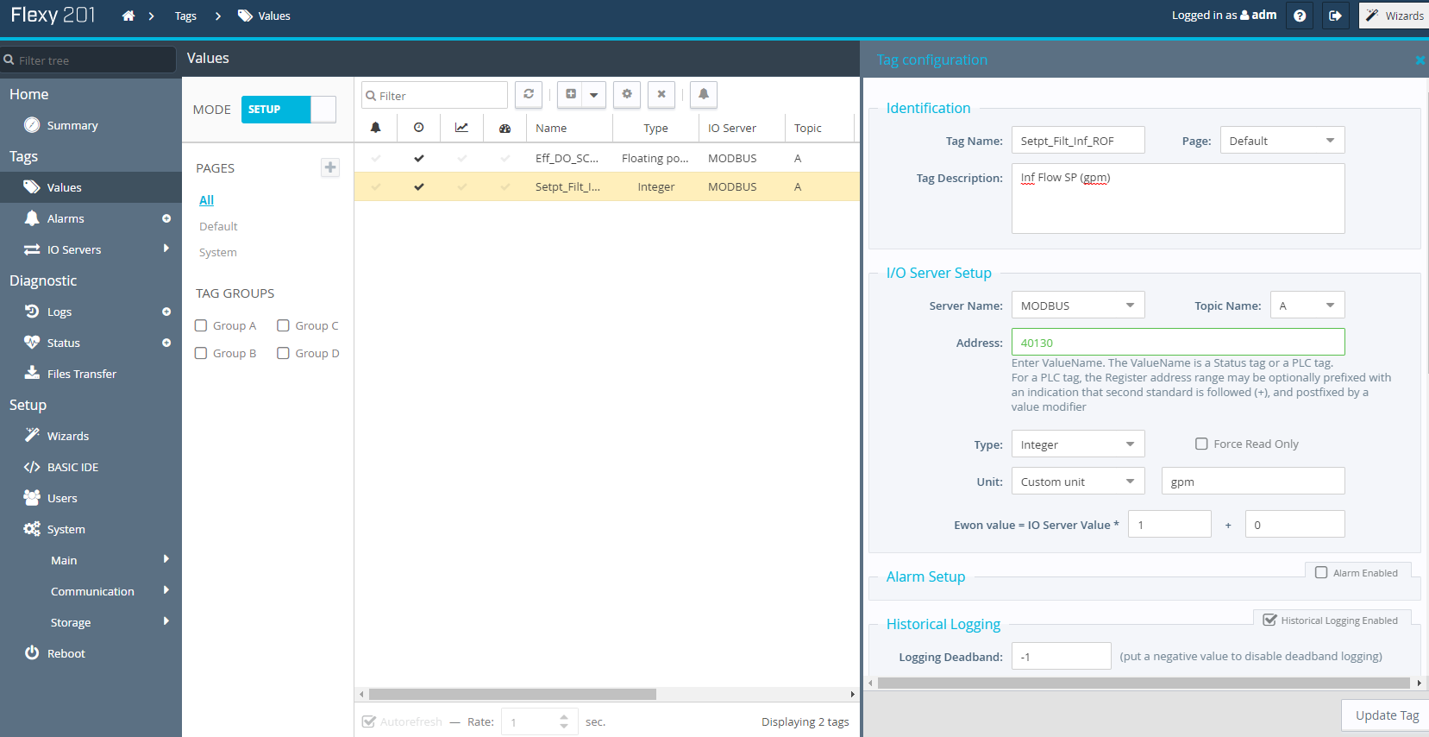

Does below “Modbus TCP” need to be Enabled? What does “Register” enter box mean?
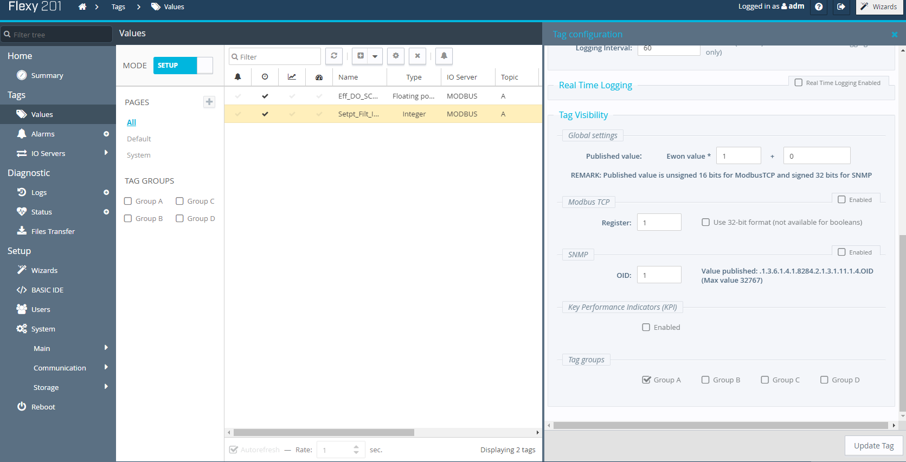
Below is the View page of tags, the reading values are correct with my above setup, but wondering why a tag address needs to be shifted by 2 (REAL type) or 1 (INT type) in eWON comparing to PLC tag address? I wasn’t able to find a good manual for my questions.
