Basic setup for EoE with an M40
Doc Created By: Tim Beaulieu
Version 1.0
Created 7/30/2019

Contents
Requirements: 2
Step 1: Creating Sharable Tags 3
Step 2: BASIC IDE Code 3
Step 3: Sending data 4
Appendix: 5
Developer ID Link: 5
Full Code: 5

Requirements:
- OpenVPN Tap V9 Adapter
- EC-Engineer or TwinCat
- CompactCom M40
- PC with an Ethernet Port directly on it (No Switch)
- SDK Code
- WinPCAP

Initial Steps:
- First thing you need to do is make sure that you have a cable running directly from your PC to your M40 (No Switch)
- After that, to start with run the default SDK code
- Once this is done can you open the Ethercat ESI Generator and make sure for the network adapter you choose the adapter that is directly on your PC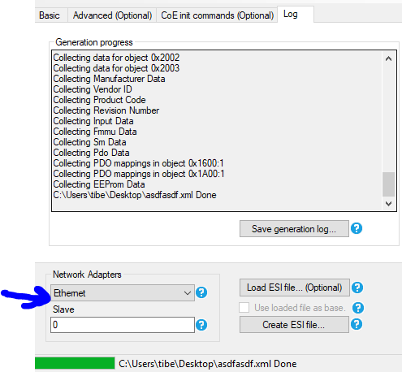

EC-Engineer Steps:
- Once this is done you can go onto EC-Engineer and select a Class A connection.
- Now you'll want to grab your ESI file that you've created and go to file > ESI Manager and add the file for the ESI you created. Then hit close
- Once that's done, make sure that your network adapter on EC-Engineer is set to the Adapter connected directly to the M40, then hit select.
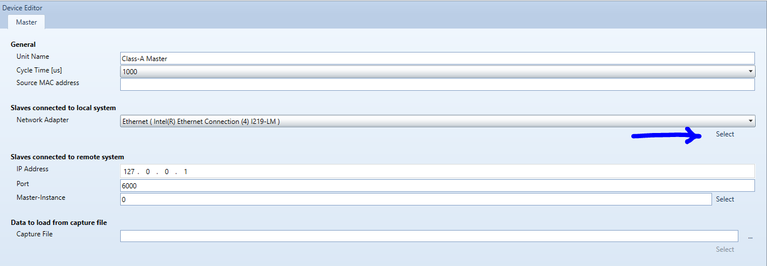
- Now you'll need to go to network > Scan EtherCat Network and it should show the M40 is connected
- For the OpenVPN Tap V9 Adapter, you'll want to choose the IP address to be in the same subnet that your M40 will be in.
- Go to Network > EoE Endpoint and select the Tap adapter you've created
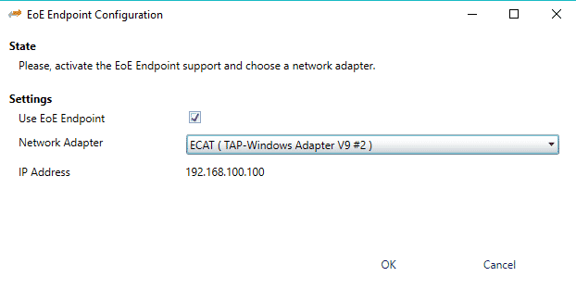
Now go and set the device into Diagnosis Mode and set the device state to Operational
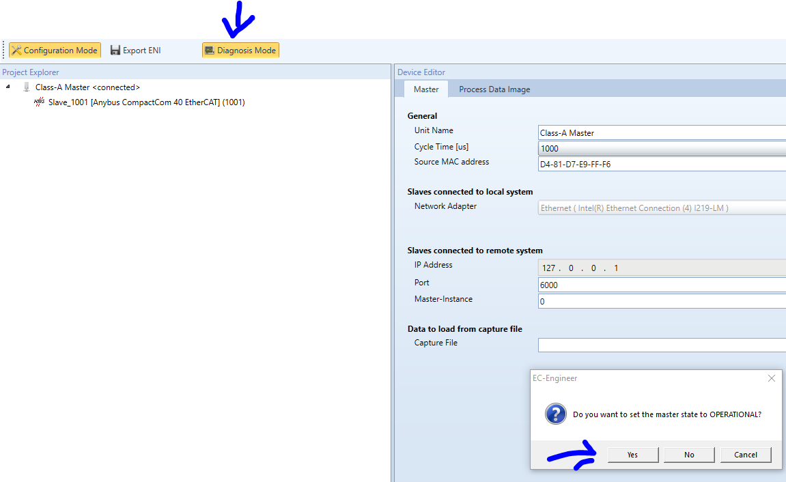
Now the device should be showing up in Ipconfig and should allow you to open the devices webserver.
