Serial Port Configuration:

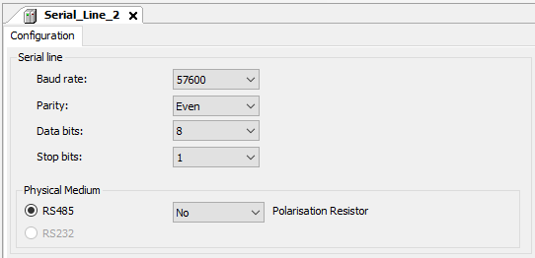

Modbus Configuration:
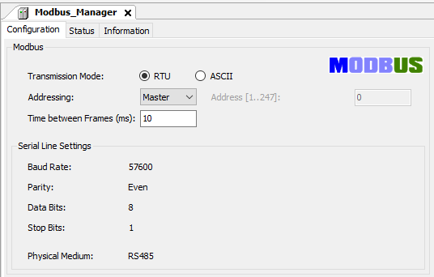

Read Block:
The read block is working fine. After finishing the reading from the gateway, the done bit change from 0 to 1. The communication error is 0 all the time.
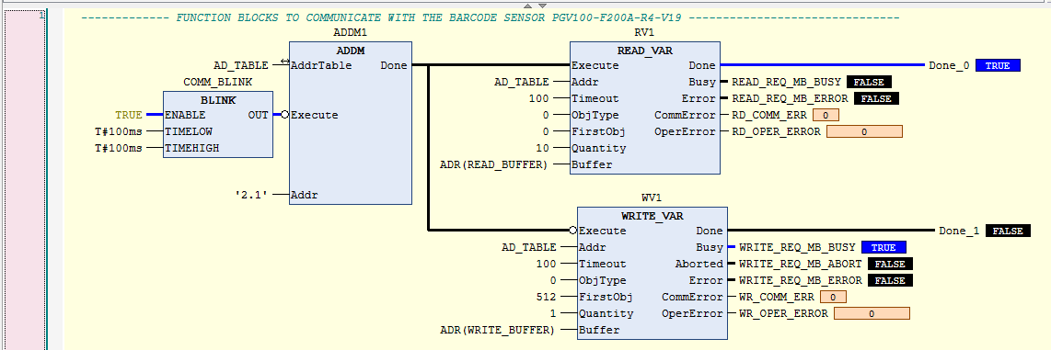

Write Block:
When the PLC is trying to write to the gateway the communication error change from 0 to 254 (FE) and the operation error change from 0 to 2
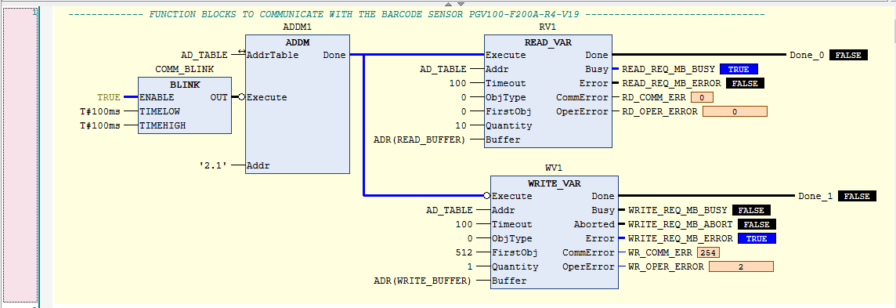

From the help of the block, we can see the following:

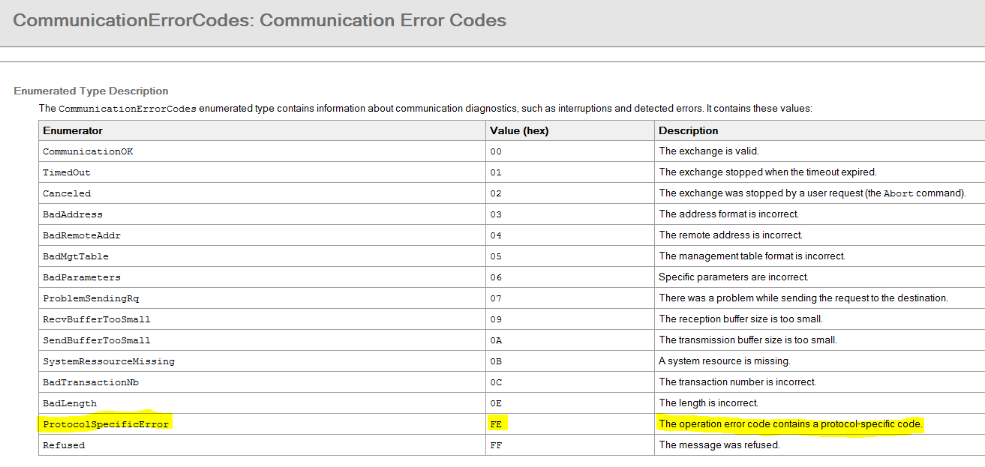
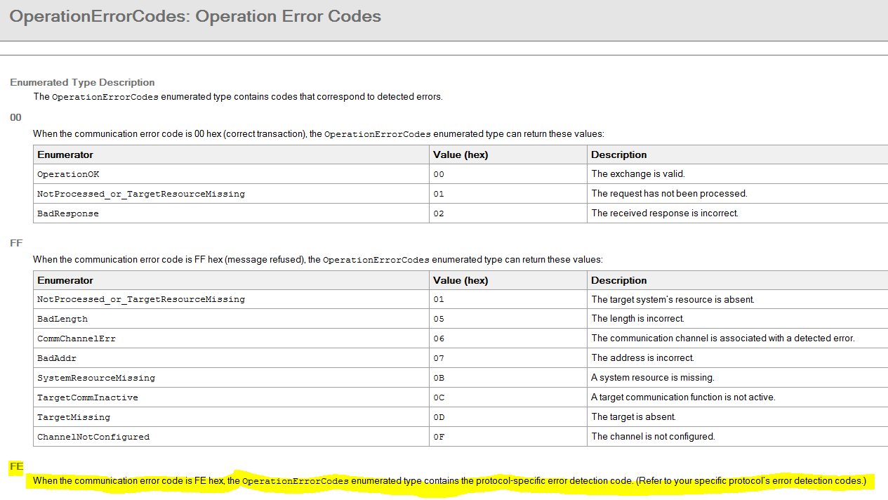
The code #02 from the Modbus RTU is:
