analysis of SIKO_AG03_1_20150311.eds

Import Warnings
These warnings can be ignored because they notify that the default value is missing
- missing entries of the PDO mapping
  - ignore it because these entries must not be provided due to the static mapping
- missing default values of index 1011h
  - these values are not relevant for the generated configuration

PDO mapping

SIKO device does not support dynamic PDO mapping
- therefore the mapping is blocked that is indicated by in front of the PDOs
SIKO device does not provide more mappable objects than displayed by the tab: Application Objects dynamic PDO mapping
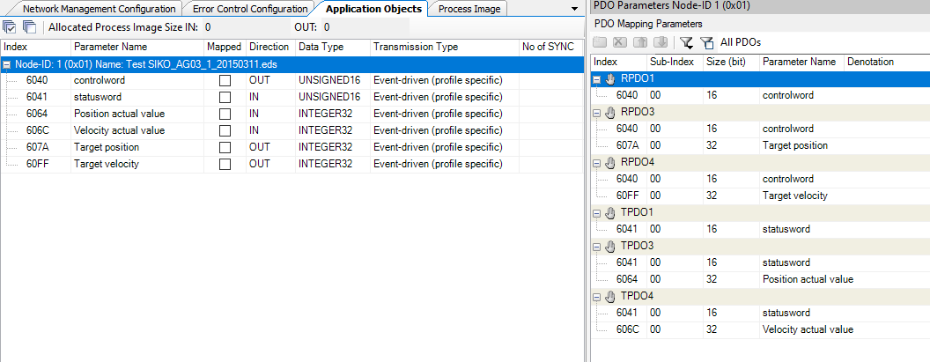

Overview of the object dictionary
The tab
Device Parameters Node-ID xx
gives an overview about the object dictionary of the device .
This overview does not contain the objects that are configured by the tabs
- Network Management Configuration
- Error Control Configuration
  - Heartbeat / Guarding, Heartbeat Consuming
- Application Objects
  - Communication / Mapping parameters of the PDOs
  - Sync cycle time, sync producer
Note:
- These objects can be accessed by SDO commands of the PLC
  - greyed objects are read only
  - black objects can be written
Note:
- Values that must be only set once after power on / reset of the device
  - can be configured in the tab: Device Parameters Node-ID xx
  - and they will be added to the automatic configuration of the device by the CM CANopen
  - e.g: index 2410 Motor parameter set
subindex 01 Controller Parameter P
example value: 250
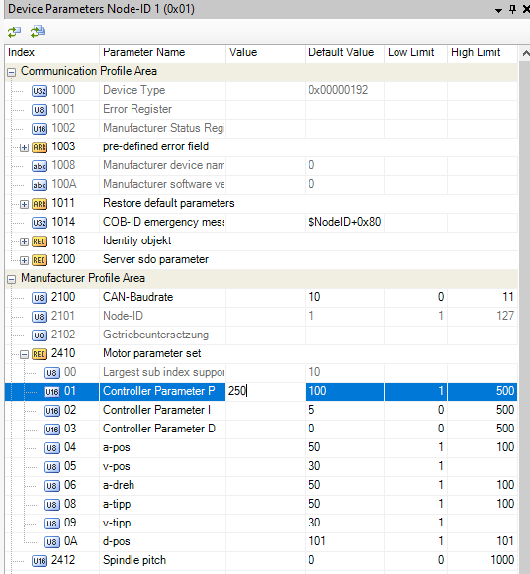

Hint: Configuration of the CAN Baudrate / CANopen node id
- the configuration of the CAN baudrate or the CANopen node id by an object entry requires
  - Restore Configuration is set to 2
to avoid that the stored CAN baudrate / CANopen node id is reset to default when the slave is booted by the CANopen manager
the slave will be booted by the CANopen manager
after power on / error control events of the slave / reset
  - see tab Network Management Configuration
- the configuration of the CAN baudrate or the CANopen node id by an object requires additional actions:
  - either CAN baudrate or the CANopen node are configured by another tool
before the device is connected to the CANopen network
  - or (much more difficult) by the PLC application

Result
It must be clarified if the EDS is correct
- if the PDO mapping is really static and cannot be changed
Contact the manufacturer of the device

