Troubleshooting VPN Wizard
Created By: Tim Beaulieu
Version 1.1
Created on: 3/6/2019
Last Updated: 3/12/2019

Contents
Points of failure: 3
WAN connection: 3
UDP connection: 3
Http direct connection: 3
Read Talk2M config: 3
Test VPN connection: 4
Procedure if the steps above don’t fix the connection issue: 4

Points of failure:
Figure 1: Showing the potential points of failure

WAN connection:

- If the failure occurs during the WAN connection, then you'll need to make sure your device is passing the internet wizard. Make sure to hit the check box near the end of the wizard that does the internet test. If that box is not checked it will not test the connection and will just save the values that you have setup for the WAN side.

UDP connection:
- If the failure occurs during the UDP connection, have your IT department look at this document and make sure that the UDP/TCP ports are open and that our servers are white listed.
https://hmsnetworks.blob.core.windows.net/www/docs/librariesprovider10/downloads-monitored/manuals/knowledge-base/kb-0209-00-en-adresses-and-ports-used-by-talk2m.pdf?sfvrsn=c86d7cd7_22

Http direct connection:
- If the failure occurs during the http direct connection, try and set your DNS in the internet wizard to be 8.8.8.8 and 1.1.1.1

Read Talk2M config:
- If the failure occurs during the Read Talk2M config, then you'll want to make sure that you entered the right activation key from eCatcher. If it shows access denied, you'll need to make sure the device is removed from the previous account it was registered to.

Test VPN connection:
- If the failure occurs during the Test VPN section, it is likely that your firewall or other security appliance performing SSL are blocking OpenVPN. This is something that is often blocked by default with firewalls such as Sonicwall.

Procedure if the steps above don’t fix the connection issue:

- Go to Diagnostic > Logs > Event Logs and set the level to Trace. Then look for other potential causes of failure. If you’re still running into issues, create a backup with support files from eBuddy and create a ticket on mysupport.hms.se with the backup included.
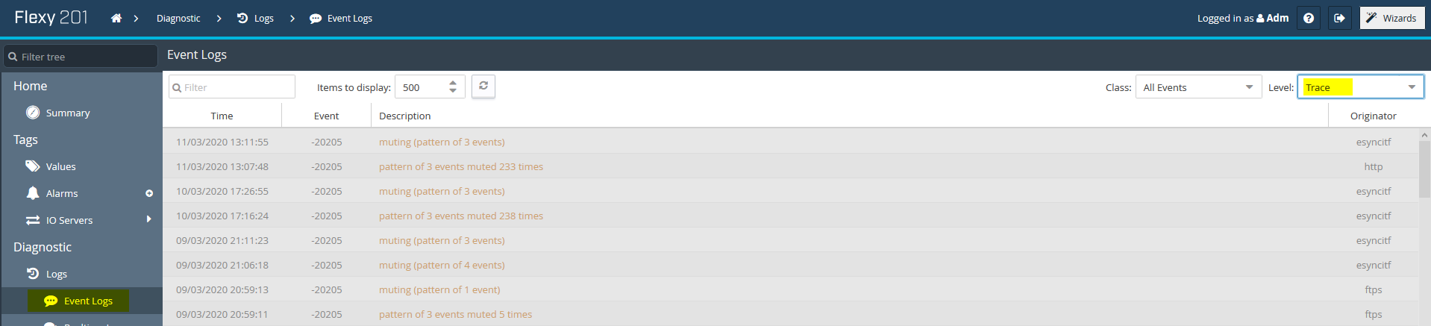
Figure 2: Event logs
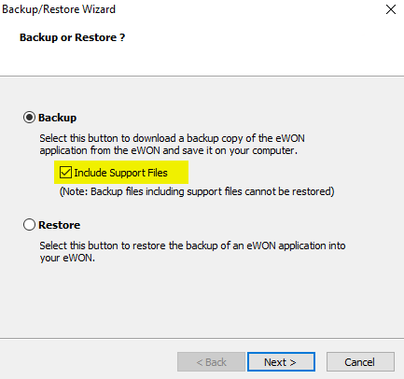
Figure 3: eWON backup with support files from eBuddy

